Costa Rica
Character Profile:
Who are you? What is your story? Why did you fit the profile for a Get Exploring Trust Grant?
My name is Jahmai Hylton, I am 17 years old and I am a Sixth Form student at Allerton High School and I have recently come back from an expedition to Costa Rica with an organisation called Camp International. During the expedition; I took part in conservational work to protect the wildlife and environment as well as helping the locals through construction and digging.
I chose to go on this expedition because I felt that I could make a positive impact and a difference to the lives of the people and the wildlife of Costa Rica. Camp International is a charitable organisation that aids different areas in different third world countries that may be economically and financially weak and may need aid in certain aspects of society. The initial target was to raise £40080 plus additional costs for kits and vaccinations; which I achieved through fundraising activities and events; and thanks to a Grant from Get Exploring Trust.
I fit the profile for a Get Exploring Trust Grant as the aims are to inspire people to get outdoors and push themselves to the limit in different environments. Through this expedition I was able to step out of my comfort zone and challenge myself in a different country, with a different climate, culture and language. The day to day tasks in Costa Rica were physical demanding. This ranged from carrying and lifting heavy equipment; to long walks from the camp to the worksite. The expedition also involved working in teams including staff, students and locals from the community to complete a variety of tasks ranging from building a special needs centre, building bird boxes, building bee hives, to making and clearing paths for the locals. The adventure element, which is the scuba diving activity, enabled me to develop new skills that were completely new to me and meant training and stepping out of my comfort zone.
Expedition Aim
What was the aim of the expedition? What was your role? What did you hope to achieve?
The aim of the expedition was to help raise the educational standards and living standards of developing communities within a rural district of Costa Rica, as well as assisting with ongoing wildlife conservation programmes to preserve biodiversity and protect vulnerable habitats. I worked in groups doing many tasks such as building bee hives, bird boxes, clearing paths, digging trenches and helping build a special needs centre.
This involved many new skills which helped develop my knowledge and character and skills; such as laying cement and filling gaps in bricks whilst helping make the special needs centre. I also dug trenches so that the locals could install pipes which can carry clean water for the locals. We made paths for locals and cleaned trees.
I helped cut wood and hammer nails in order to make bird boxes as well as bee hives. This helped conserve the nature and wildlife as well as help the locals get clean water and have a centre for special need people. I hoped to successfully complete and achieve all task given to me and to help make a positive impact and improvement to the lives of the people and wildlife of Costa Rica. I hoped to grow further in confidence and develop a better appreciation of other cultures and way of life. I also strived to develop in my fitness levels, gain new skills and be able to adapt in new and challenging situations.

Expedition Account
Week 1: We travelled on 6 hour coach journey to Camp Papagayo where we spent the week learning to Scuba Dive. During our stay we stayed in tents and had to share with two other people. The first week was hard at first as we had to learn to adapt to the hot weather and different lifestyle. Each day we got up for breakfast at 7 am. After breakfast we would all go to the meeting spot for 8 am and then do a warm up exercises to keep us awake and energised before going to Scuba Diving lessons.
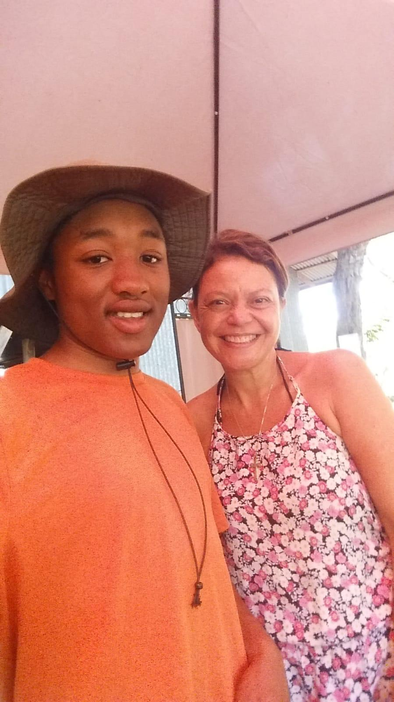For the first few days we watched videos about Scuba Diving and take part in written tests to test our knowledge. These videos would help prepare us for diving and the risks and precautions divers must take in order to remain safe. We would have our lunch at 12:30 and then would return to our lessons for 1pm. We would finish at 4pm and would be free until dinner which was at 6:30. We would meet up again at 8pm to do group activities and to appoint student leaders. On the third day we went in the pool and had to swim from each end there and back 10 times to see if were able to Scuba Dive. We then learnt how to set up our scuba equipment and had to assemble it 3 times with no help to ensure we knew what we were doing.
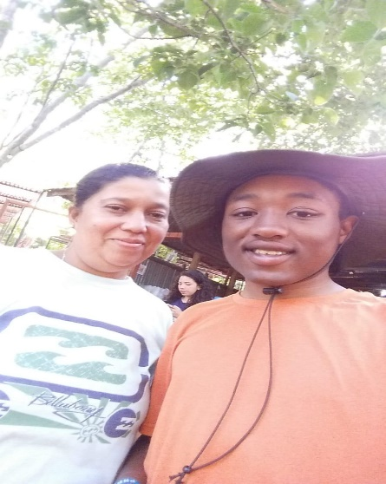
The following 2 days were spent doing practical work in the pool, learning the techniques required to scuba dive in the sea safely. I myself had trouble understanding what my first instructor was telling me to do during one of the lessons, which frustrated him so I was sent out the pool and joined another group the following day and completed all the lessons.
The next day we went out on the boat to the sea to scuba dive, we had to carry all our equipment out to the sea and climb onto the boat. The boat went far out into the sea and stopped in a certain area which was opposite a big rock which looked like a monkey. The rock helped identify the area as a lot divers go in that area. We got our equipment on however a lot our equipment got dirty with wet sand on the beach so were to wash them off oversea. However as I was cleaning my snorkel I had dropped it into the sea by accident. My diving instructor instead gave me his personal snorkel to use before we went into to the sea.
Whilst we swam that snorkel fell off and went into the sea. Then more issues arrived as when we descended into sea as my weight belt had too much weight in it so it was dragging me down, furthermore water kept filling up in my goggles and I kept having to clear it.

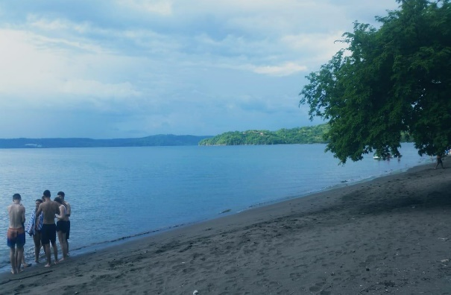
Despite this the sea was still beautiful and I saw schools of fishes swimming in the ocean. I signalled to my instructor that something was wrong with my equipment. Unfortunately a decision was made as my diving instructor felt it was not safe for me to continue diving in the sea and I was instructed to go back to the boat. I was very disappointed that I couldn’t complete my scuba diving training. However, I decided that I wanted to make my experience as positive as possible so if I am in a similar situation in the future I will make sure my equipment is on properly before going in the sea to stop the chance of this happening. What I have learnt from this is that things doesn’t always go according to plan and although it was disappointing for me it’s important to be adaptable when such things happen. Whilst others continued with their scuba diving training I joined a group of non-diving students where we made a poster about the different animals and wildlife of Costa Rica which we presented to the rest of the group later in the day. Although I did not achieve my PADI Scuba Diving certificate, I did successfully complete a Coral Reef Conservation speciality certificate. This is a non –diving certificate which helped me learn about the coral reef habitats and taught me how to take care and conserve these systems.
I learnt about how sharks are not like how they are portrayed in the media and that most sharks stay away from humans as they fear them. The next day people saw sharks whilst scuba diving, we were told that sharks are often hunted for money and that it is damaging the eco system. We were taught to spread awareness for sharks.
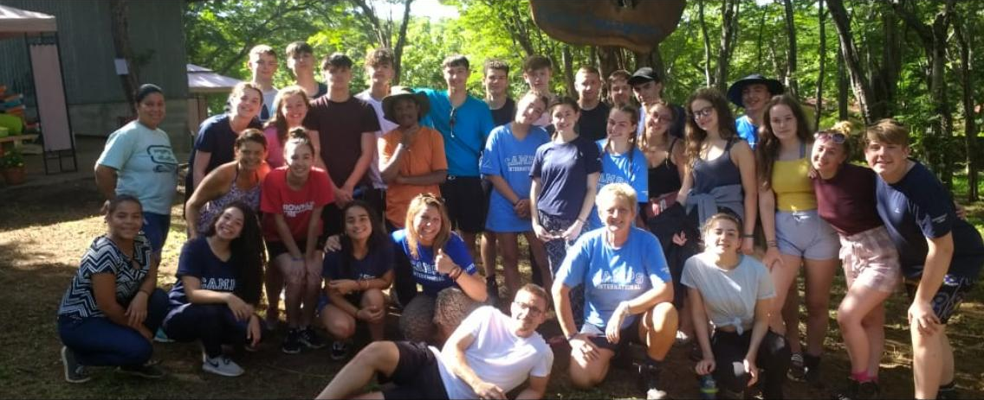

Week 2: Cano Negro
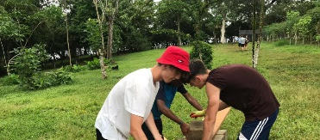
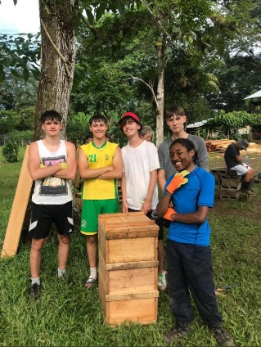
During our stay in Cano Negro we stayed in dorms with 6 people in each room. We had a free day the first day we got there however the following days were hard work.
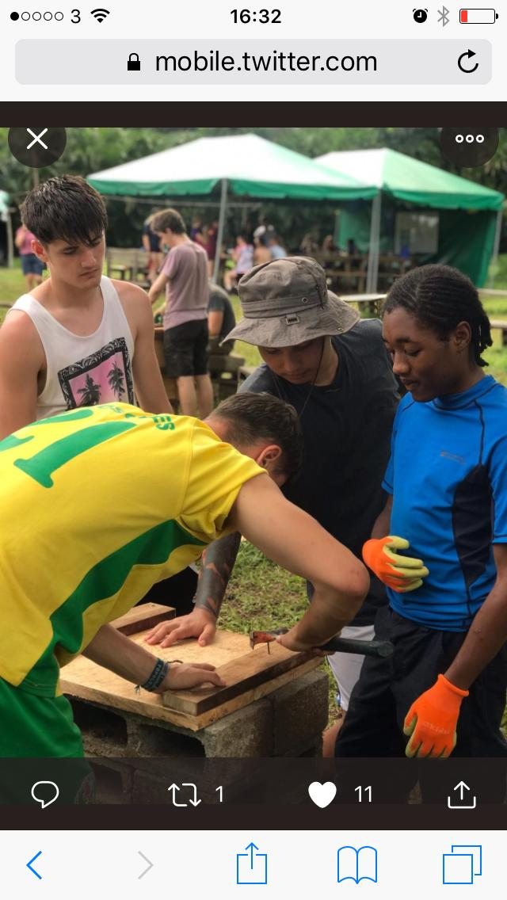
In Cano Negro the main task was making the different parts for bee hives. This meant that we had to do a lot of wood cutting and sawing, making sure the different pieces of wood were the right length. However, we faced many challenges as our equipment was inefficient and because it was raining season the wood would often get wet, making it harder to cut through.
In order to solve this, next time I would suggest we all find something to cover the wood so that it wouldn’t get wet in the rain.
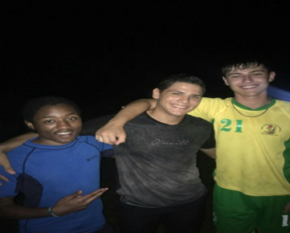
Despite this challenge we all worked hard cutting and assembling different pieces of wood using hammers and nails to keep it together. We also went out to the woods and cleaned trees and cut off weeds that were growing on it so that they could be painted over so that the locals can follow the path and no where they are going. Originally we were going to paint the trees but because of the rain we realised it would wash the paint off.
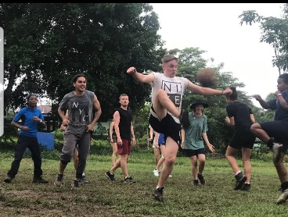
We also helped build a shed for compost. We blocked the holes so that animals couldn’t get in and we hammered wood together to make sure that it was stable for the compost to go in. One afternoon we got to play football with the locals and sometimes we’d watch them perform on an evening whether through singing or salsa dancing.
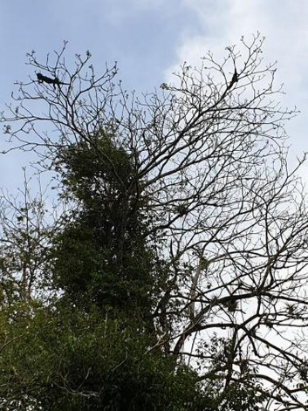
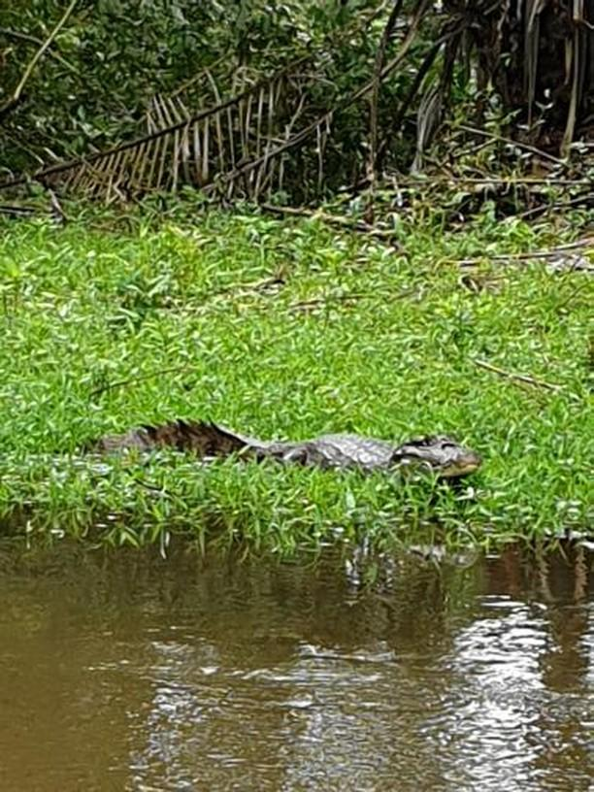
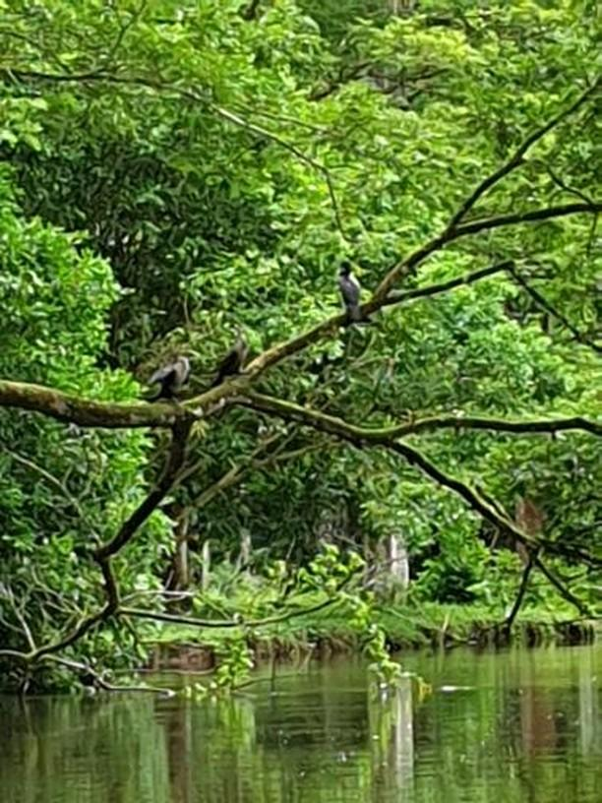
On the Monday we went on a boat ride where we saw lots of different animals such as birds, crocodiles and iguanas. Costa Rica accounts for only 0.03 percent of the earth's surface (has only 51.100km2). However it contains nearly 6 percent of the world's biodiversity. Its natural wealth, both in species and ecosystems, is partly explained by its geographical position. This was all available in this area.

We had to stay very quiet on the boat when we got to certain points so that we didn’t frighten the animals. It was a really great experience, seeing so much nature and wildlife.
We had to get up early (between 6-7 am) for breakfast and we had to eat it quite quickly as there were lots of bees around that were constantly trying to swarm your plates. This was quite overwhelming at times especially when we first got to camp.
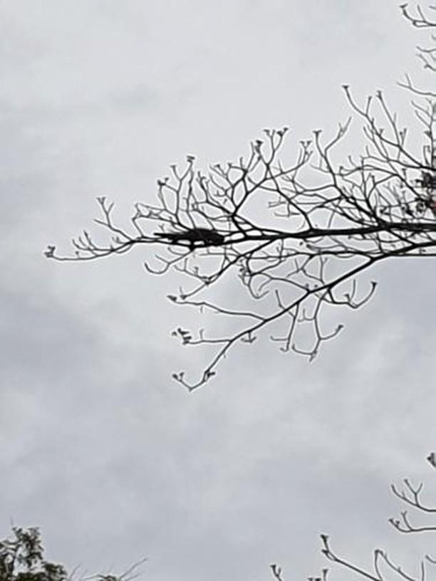
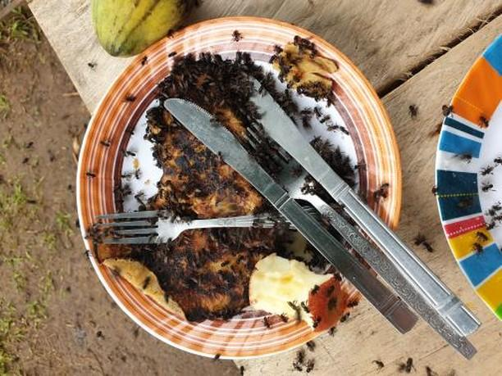
Another person in my group left their food out. This was the result. We all soon learned not to put honey on our pancakes.

(Cano Negro)
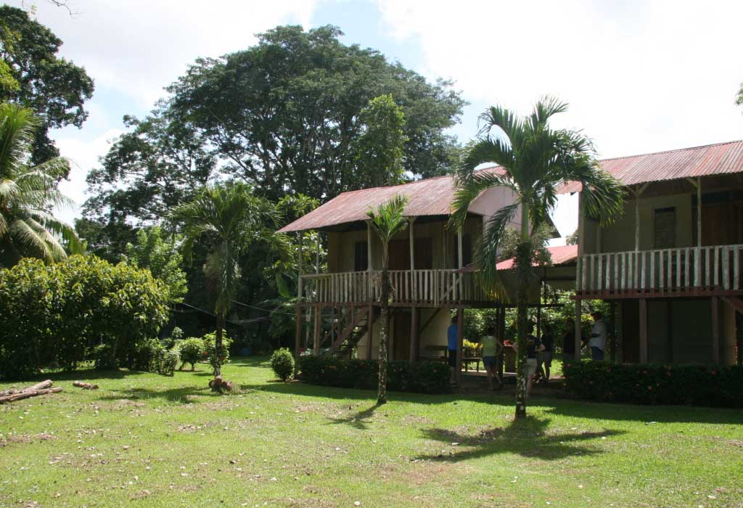

Week 3: Camp Osa
In Camp Osa our main focus was wildlife conservation. We achieved this by doing many tasks such as building and placing bird boxes, clearing paths, setting camera traps and making paths for people to walk. During our stay we stayed in hammocks and blow up beds. When building bird boxes we had to figure out measurements and cut and nail wood with equipment such as a saw and a hammer. It wasn’t easy as we had to cut the wood at an angle and our equipment wasn’t in the best condition, making it much harder to use. The wood was thick so it took longer to hammer in the nails but we accomplished our task and made bird boxes.
We set the bird boxes in the forest and had to tie them to the trees using wire and place them in a position that gave bird’s easy access. Next time I would make the groups more mixed by having an even number of boys and girls in a group as the group which was mostly girls took the longest to make the bird box as it required more physical strength to make it.
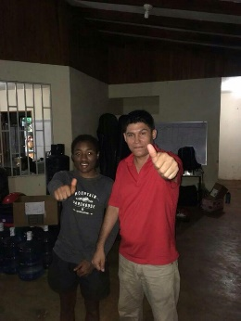
Some days we would go out and clear paths so that the locals could walk through the forest. We would use shovels to get rid of any sticks or rocks in the way and to flatten the ground. The ground was a muddy red in Osa and because of the rain the ground was soft allowing us to carve stairs down the hills that people could walk down. We continued making and clearing paths for the locals. However, because the ground was so muddy it made it hard for people to leave the camp. To solve this we used mud and hammered in the ground across the path to make a small fence on each side. We then poured gravel along the path and spread it out in different sections to enable people to walk along the path. We did this by shovelling gravel onto wheelbarrows and then taking the wheelbarrows down to the path to pour whilst another group would spread the gravel along the path. We managed to do this efficiently and effectively. Then our task became much more challenging as we were told that we had to make paths inside the camp too which was difficult as we had to go down a really steep hill and a long flight of stairs to get back to camp. This meant we had to figure out how to take the gravel down to camp. We then came up with the idea of using the wheelbarrow to bring the gravel down to the stairs and then pour the gravel in buckets and then have people stand across the stairs and buckets along until it reaches the camp and then take the buckets back up again. We did this numerous times, myself at the very top of the hill had to walk down with the bucket before passing it on; although it was a lot of hard work we were determined to complete our task which we did effectively and efficiently. This experience taught me lots of new skills and problem solving, which was show when we figured out how to get the gravel to the camp. We also did tasks like replanting flowers by cutting them out in certain areas and planting them down in the camp in order to attract more bees and butterflies to pollinate them near camp. We also placed camera traps in the forests so that we can track the Jaguars that live there and get pictures of them.
The locals were incredibly kind and friendly and I really enjoyed this camp despite how muddy it was.

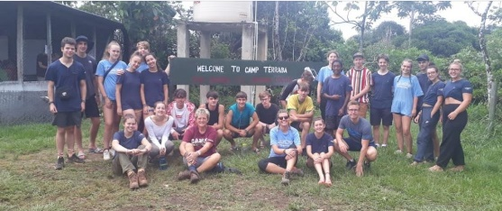
Week 4: Camp Terraba
This camp was by far one of the best camps in the whole expedition. Throughout our stay we stayed in dorms, 7 people per room, meaning we had our own beds. We had to have bucket showers however they were good and the water wasn’t that cold.
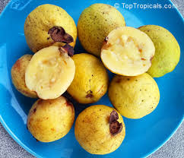
This camp was of the hottest by far. We got to interact with the locals a lot more as every day after work we went to play football with them.
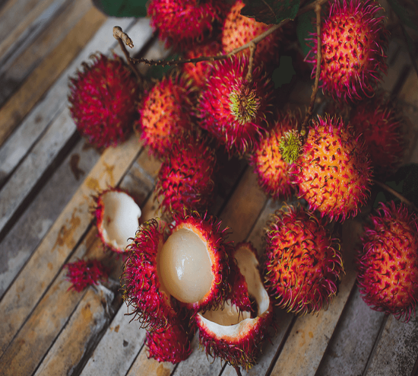
There was boy called Dylan (pronounced Dye Lan) who picked up a fruit from the ground and broke half of it off for me. He spoke Spanish so I couldn’t understand him fully but he pronounced the fruit (Guajabo) but from my own research I discovered the fruit was written as Guava. We gave a football kit to the local children and we did lots of work to help the community, such as helping to construct an S.E.N.D centre (Special Educational Needs and Disability Centre) as well as digging drenches for water pipes to through and levelling the ground. I felt that this work was very important for the locals and was eager to make a difference to their lives.
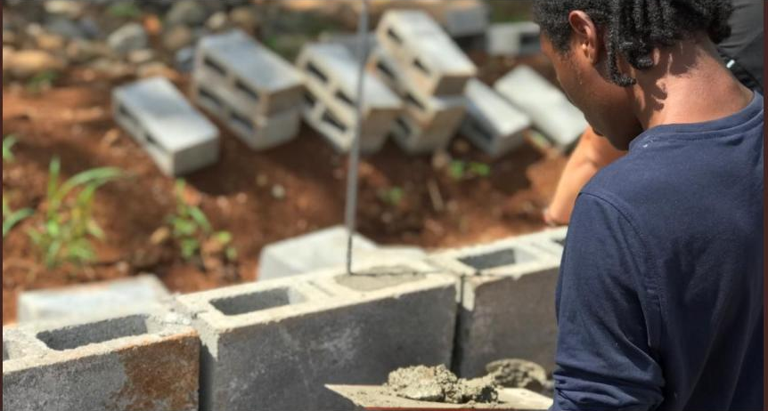
Through us digging the trenches, the locals would be able to install pipes that would provide clean water to the locals. Furthermore, the S.E.N.D centre would really make a positive impact on the local people with special needs, as they really need a place where they can get the support and help, as well as a place they can call their own. I had learn new skills working on this project such as laying bricks and filling gaps with cement. I also learnt how to pickaxe and shovel whilst digging trenches and also how to level the ground for the S.E.N.D centre with the shovel.
(We also ate Rambutan, another fruit native to Costa Rica.)

Overall, I really enjoyed this expedition, it was an amazing experience and it helped developed my confidence and enthusiasm in many ways. I am happy to have been able to make a difference to the lives of so many people and have helped protect the wildlife and nature of Costa Rica too.

Financials
Give the reader a breakdown of where you secured your money from to pay for the trip. Where else did you get your grants from? What did you raise yourself? Any tips for others finding it hard to raise money.
I secured the money to fund the expedition through fundraising and events and a grant from Get Exploring. I had a lot of support from family and friends through sponsored events such the jog and swim I took part in. My local supermarkets were particularly helpful as I was able to book in bag packing dates with the community champions. The important part is to have family and friends who are willing to bag pack for a whole day for each booking. My local Co-op were amazing and the managers welcomed me in to fundraise, bag pack, and hold a cake and tombola sale. My top tip is to email, call or go into the store to see the community champions in store. Bag packing has been my biggest fundraiser. Anyone planning on doing bag packing should were comfortable shoes, be prepared to talk to customers and explain what they are fundraising for as customers are interested and want to support a good cause.
Get Exploring Trust Grant £350
Bag packing from local supermarkets £1929.61
Sponsored jog £388
Sponsored swim £255
Summer Barbecue £101
Just Giving Page £335
Easy Fundraising £70.18
Fundraising at Local Co-op £972
Cake sale and Tombola £133
100 Square Mother’s day hamper £100

Highlights
What was your best experience?
Working on the S.E.N.D centre and getting to know the locals, as it was a very important to the locals and for me personally as it was important work that is actually making a difference to people’s lives. I furthermore, enjoyed getting to know the locals, having deep conversations, playing football and watching them perform. We also gave the local children a football kit. Seeing them all in it smiling and happy was a beautiful experience.
What did you find most challenging?
I found making the bee hives most challenging as it took a lot of physical effort and was challenging in many ways, such as the fact that the tools we were using were quite blunt and ineffective for cutting wood. Furthermore, the wood was thick and difficult to cut through and if we got the measurements slightly wrong we would have to do it all over again. Additionally, because it was raining season, it would often rain heavily for short periods of time throughout the day, wetting the wood and making it harder to cut through. Despite these challenges we overcame them by working together.
What did you learn?
I learnt that it’s important to ask for help and to work as a team in order to get things done quick and effectively. I also got a deeper understanding of the daily life of people in Costa Rica and how much harder it is for them than us as a lot of people there struggle with money and some can’t afford to leave their village and travel neighbouring cities because they need to have enough to support themselves and their families. I learnt that every challenge you face, whether physical, mental or spiritual is all designed to help you grow into the amazing person you’re destined to become. Costa Rica gets most of its income from tourism so us doing this expedition in that country is also highly beneficial for them as well as the project work we were doing. I learnt about the environment and how the animals often avoid people. I also learnt about how sharks are being hunted and are nearly extinct, and if we don’t do anything to stop it to ecosystem will collapse. This is the same for a lot of animals in the world and the government refuse to do anything about it. The people in Costa Rica work hard to protect the environment however we were told that it wasn’t enough as they only had 5 or 6 people to cover a specific area of the country which is not enough to stop poachers from hunting animals. I also learned that the media portray the animals such as sharks in a bad way as most sharks won’t attack humans unless provoked. This is evident as people who went Scuba Diving saw sharks and were perfectly safe. The fear of sharks mostly grew when the movie jaws was released.

Get Exploring Trust I have benefited so much from your support. I feel more confident and my self-esteem is much higher. I feel more comfortable working with others whereas as before I would prefer to work alone and didn’t interact much with people that I didn’t know. I got to know people that I didn’t really speak to at school. I got to create memories with the local people in Costa Rica and was able to make an amazing contribution to their lives through the work that I was doing whilst there. I feel happy and proud of myself and I am very grateful for the support that Get Exploring trust has given me.

What next?
I feel more confident to try new things and meet new people. I plan to have a gap year before going to university to gain some experience in working with music and writing books; as well continuing with extra-curricular activities such as performing arts classes. I may also do some travelling too. Once again I thank Get Exploring Trust for supporting me and helping to give me the opportunity to travel outside of Europe for the first time, and gain new experiences whilst working and making a difference to the lives of other people as well as my own.

