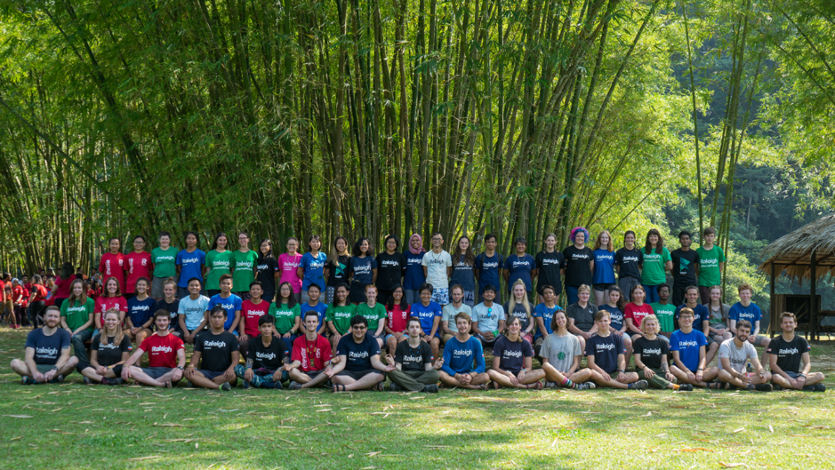

Raleigh International. Borneo 2018

Megan Kirk

Firstly I’d like to say a massive thanks to you all at the Get Exploring Trust for supporting me and kindly giving money to aid my fundraising to help me complete the 10 week expedition to Malaysia Borneo. By the time you are reading this it will have been a fair few months since my expedition, but I will have not forgotten the experiences I have had and the skills in which I have learned during the incredible journey I had with Raleigh. I hope to take these skills forward into my future whether that be work, volunteering or personal life. Hopefully this write up will allow you to get an insight into the work myself and other volunteers completed, the things we achieved and what I learned.
My name is Megan Kirk and I currently Live in Fife in Scotland. I applied to the get exploring trust grant as I was in need of financial support for the volunteering expedition I was going on to Malaysian Borneo. I may not have fitted the profile exactly as I have recently graduated from University and was working to fund the expedition. But after having a phone call with one of the trustees and explaining my desired outcomes and background they felt I was suitable for some financial aid. I have structured the report to give a bit of background on Raleigh and why they are such an amazing charity to work with and why I chose them. This write up will allow you to get an insight into the work myself and other volunteers completed, the things we achieved and what I learned.
Who are Raleigh International?
- A UK based charity that was started in 1978 Operation Drake
- Became Operation Raleigh 1984
- Raleigh International 1992
Operation Drake was a 2 year long voyage with the purpose of carrying out scientific research globally. The voyage took people aged 17-24 from all over the world to help carry out the research.
This became operation Raleigh in 1984 global expeditions continued on 2 renovated ships. Raleigh international was established in 1992 to represent the global community it strived to create. The focus shifted to land based expeditions in poverty stricken communities and it has continued to grow since then.
The Raleigh Values
- Find the courage
- Open to discovery
- Never give up
- Create impact together
- Act with integrity

The Raleigh core values aid the development of young people, helping them gain skills they can carry through life. I felt that the values represented some values I carry in my day to day life and skills I wish to develop also. These values help Raleigh not only just take a bunch of young people to poorer countries to do manual labor. These values ensure that the development of volunteers remains extremely important , just as important as the work they are doing.
What do they do?
Raleigh uses the power of young people to create lasting change in certain areas across the world. They work closely with local people with aims of improving water, hygiene and sanitation, projects focusing on improving environmental issues and maintain a belief that a global community of young people will help drive important change in the world. They hope that volunteers return to their hometowns and continue to want to help and contribute in some way.
Why young people?
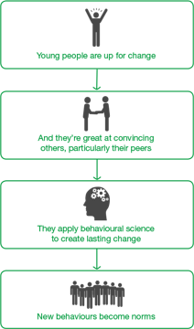
Raleigh believe that young people have the drive, commitment and open mindedness to not only create change but also embrace change.
They believe young people are ready to start creating a world that they want to live in and have the ability to encourage others to make positive lasting change all across the world.
I feel The Exploration Trust have similar beliefs as they support and inspire young people to get involved in exploration and adventure.

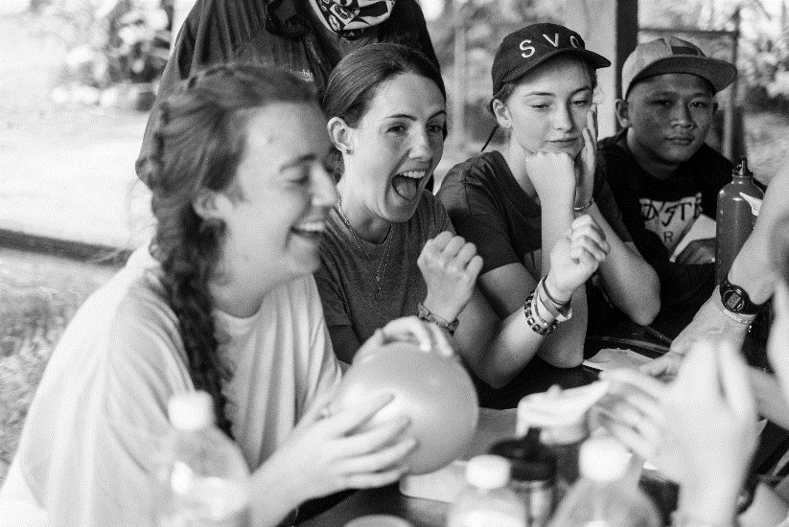
Why did I choose Raleigh?

- Focus on SUSTAINABILITY
- Avoidance of toxic voluntourism
- Importance of Host country volunteers
- Established and informed charity
- Already have made positive, lasting change
- Trek phase-Personal journey

I had been thinking about Raleigh for years after seeing a friend had done it. It was something that really appealed to me but I never really found the right time between working most summers and university studies. After graduating I ended up on the website again and decided I was too old being at the latter end of the age range (17-25). However, I ended up looking at the website regularly, almost daily, between working and volunteering in Scotland and with a prod from my family decided it was something I had to do. Now or never eh?
Raleigh International have a very informative website that provides information on what they do, why they do it and the success that they have had. From the website I could tell they were an extremely caring and focused a great deal on the development of volunteers involved in any of their projects. They work across the globe so it was hard to choose a destination. I was always very keen on experiencing life in the jungle so Borneo was the place for me! They have an amazing relationship with not only companies in Sabah, Malaysia but also the local people as they have spent 31 years building trusting relationships in the area. It was important for me to avoid a charity or volunteer experience that often, granted unintentionally, do more harm than good. Raleigh involve local people and communities to ensure the projects are well supported and don’t crash and burn when volunteers leave. They are experienced and have learned from mistakes in the past and strive to continue great meaningful work. They put a huge emphasis on education of local people and the international volunteers and this is vital for success and longevity of any project work and continuation of impact when volunteers reach home. This was all evident before my Raleigh expedition and I can truly say they lived up to expectations and have a wonderful program in place.
Raleigh expeditions are split into three phases and in Borneo the 10-week expeditions are split into an environmental, Community and Trek phase. I read up on this before applying and thought it was an extremely well-rounded approach to a 10-week expedition it meant I’d be getting experience in numerous environments and gaining a variety of skills too!
Trek phase particularly appealed to me as I am a keen hillwalker and camper and thought a 16-day trek was quite a challenge indeed!
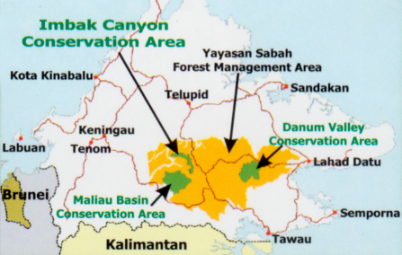
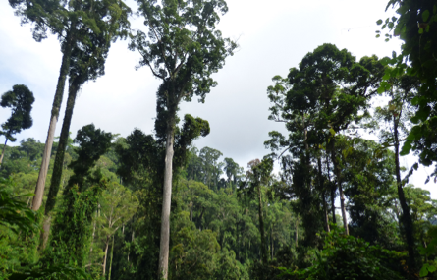
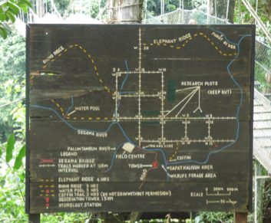
Phase 1 Danum Valley

- Raleigh has supported work in Danum since 1987
- I was involved in contributing towards the work carried out to help build a suspension bridge over the Segama river
- Protected area, 438 square meters (size of Singapore)
- Home to a unique variety of flora a fauna appealed to my interest in animals and environment
- An astounding place to live for 3 weeks

Danum valley is 438 square meters of lowland dipterocarp forest. Danum Valley Conservation Area is a Class 1 (Protection) Forest Reserve, under the Sabah Forestry Enactment 1968.
The forest is 130million years old home to a huge variety of flora and fauna including pygmy elephants, orangutans and Sumatra Rhinoceros. It was an absolute dream to be able to live and work in this rainforest. The environment was glorious. However, doing physical tiring work in the humidity and heat was extremely challenging. We were there as part of an ongoing project that is building a suspension bridge over the Segama river. The bridge aims to improve access to the research plots and aid fundamental scientific research. Danum Valley hopes to achieve UNESCO world heritage status and the bridge is a component for the criteria for this.
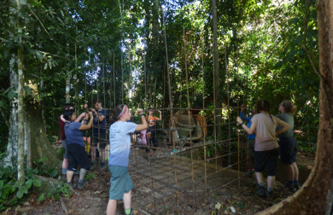
Physical work
- Gravel collection –Raleigh chain!
- Steel frame building
- Hole clearing and cement mixing
- Camera trapping
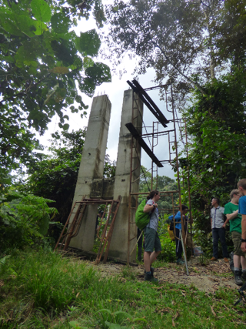
- Helipad clearing

Steel frame
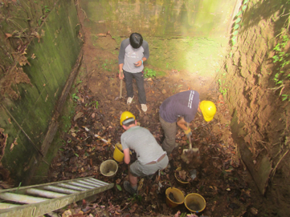
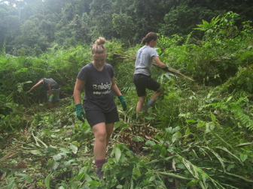

Site A
Hole clearing
Helipad clearing
Site A was on the side nearest the road and previous expeditions had completed the foundations for bridge attachment and was basically the blue print for how Site B should look by the end of the 10 weeks.
Site B was where we spent the 3 weeks working. On arrival and inspection there was a 10m x 10m x 10m hole that had been dug by the previous group. The aim for our 3 weeks was to collect gravel that would be used in cement to fill the hole. The gravel was collected from the riverbank and transported to Site B by us using a good old Raleigh chain! We also had to move the cement mixer to the edge of the hole (much harder than we anticipated in the rainforest). We had to construct a steel cage that would provide reinforcement when cementing the hole and the hole had to be cleared of Debris. The steel frame required a great deal of time as steel rods were moved to site B, straightened then bent into shape and secured together by wire. All the word was completed without the aid of any machines, except the cement mixer. Whilst there we also cleared the helipad of vegetation and set up camera traps on one of the trails. Clearing the Helipad ensures safe access to the puruit camp site in case of emergency. The camera traps are part of ongoing research into animal population dynamics in Danum. The camera trapping not only allowed us to see some very interesting animals but also aids research into animal movement and species richness. This allowed volunteers to gain an insight into the sheer biodiversity and unique balance of the Danum Valley ecosystem.
By the end of phase 1 we had managed to achieve the aims for phase 1. In addition, we also moved over 40 bags of cement from the roadside in Danum to Site A ready for transportation over the river by phase 2 volunteers.
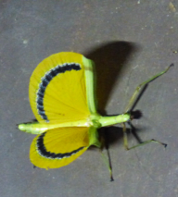
By the end of the expedition, Hole filled with cement, steel frame and concrete pillars erected at site B
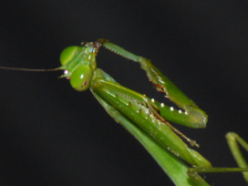
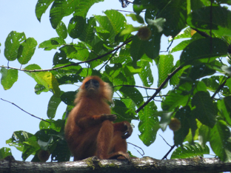
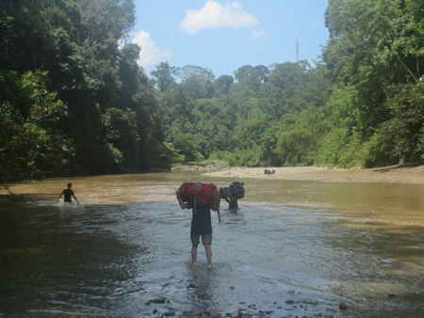

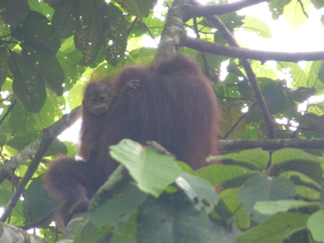
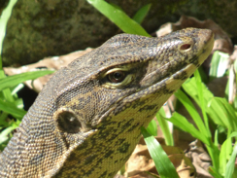
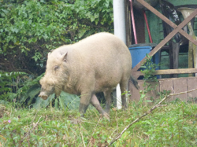
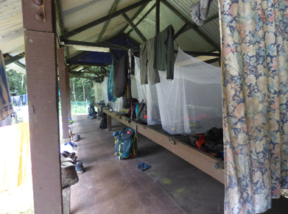
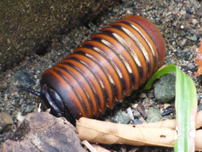
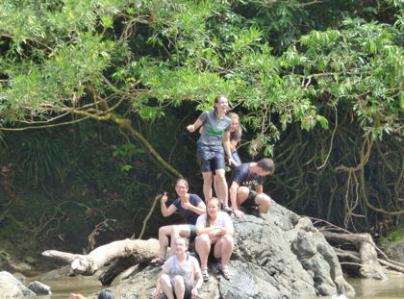
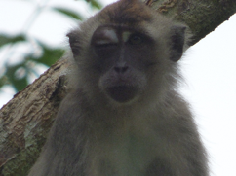

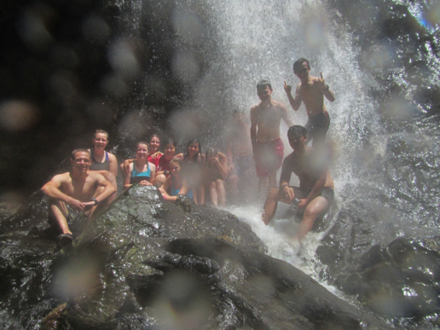
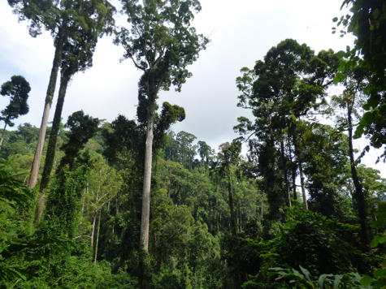

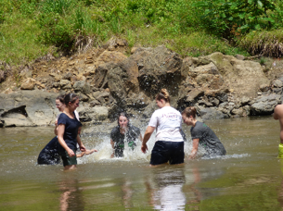

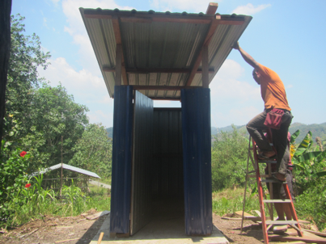
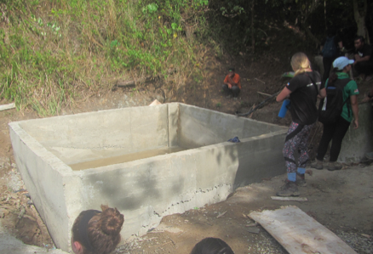
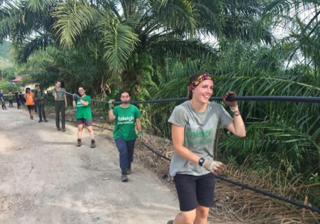
Phase 2 Kampung Mempakad

The UNDP (United Nations Development Programme) identifies Sabah as the poorest state in Malaysia. It reports that 25% of households lack a regular water supply, and significant numbers of rural households depend on rain and river water sources which can be irregular and unsafe. Kg. Mempakad was a three-phase project to build three tandas’(toilets), a dam, reservoir and gravity fed water system as well as introducing a maintenance committee and raising awareness of waste management.
Mempakad was situated in the North of Borneo. The village haven't had access to a clean or reliable source of water in 50 years. There are 300 residents and those with cars would drive to get water, those without would walk to nearest source or buy in water. Illness is common due to lack of hygiene and handwashing facilities and just a lack of education about hygiene importance.
Physical work
- Helped complete the Dam walls and seal the structure (lots of concreting!)
- Dug trenches to lay piping from the dam to the main road passing the village(5km) using hoes, spades, shovels, pickaxe… anything we could!
- Completed 2 toilets and 2 handwashing sites (tippee tap) dug trenches and deep holes for septic tanks
- Delivered an education day on health and hygiene to the village. Made posters and activities for the children
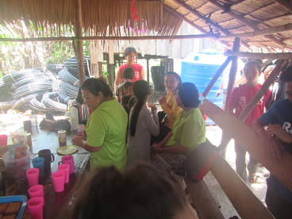
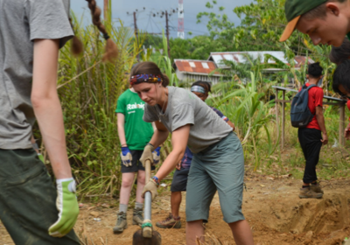
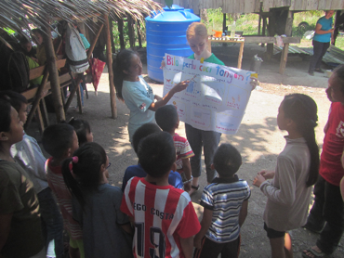

Time with the villagers in the bamboo hut
Digging hole for septic tank behind Tandas
Educating the children on handwashing
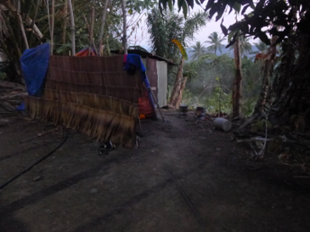
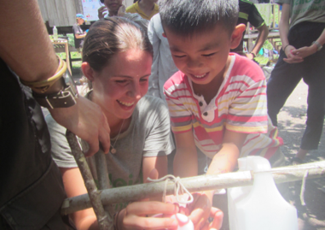

Our “shower” and toilet area
Using the tippee tap to show the children handwashing
By the end of the expedition
Water delivered to 38 houses , 3 handwashing sites 3 toilets situated at chosen sites in the village. Education on waste management and health and hygiene for all residents so they can use and look after the new facilities.
This phase taught me a great deal about community spirit and truly appreciated and using what you do have and not yearning for what you do not have. Integrating with village events such as church and dancing gave me a true sense of how welcoming and caring people really can be. Despite having very few possessions the villagers were extremely happy and really worked together in a completely selfless way. They would always be working just as long and as hard as us and really took ownership over the project. We stayed in a wooden house in the village and at one point 20 of us were squeezed into this small house. It was truly a lesson in getting on with your peers and learning a great deal of cooperation and understanding. As the village had no running water neither did we. We bought water in for drinking and cleaning our kitchen utensils. This water was highly rationed and each volunteer was entitled to 3 buckets of water for the 3 weeks. I used mine for 1 “bucket shower” a week. Never have I been more careful with water. One bucket full would be used to wash my hair, body, clothes and then used to flush our toilet (a porcelain hole). We all came up with ingenious ways to wash ourselves to save as much of the water as possible. I adopted a sock with a bar of soap inside as a way of washing myself most effectively. It was hilarious at times but always reminded us of a serious job we had to do as for the villagers this was an everyday reality. It was a real eye opener as to how lucky we really are in the UK as we can turn a tap or flush a toilet and always have access to not only water but clean and safe water.
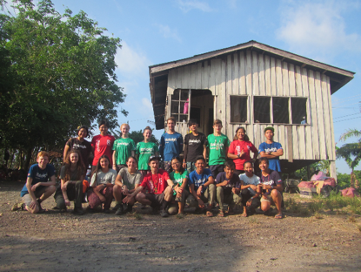
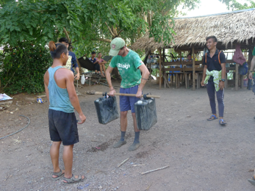
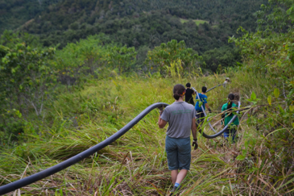

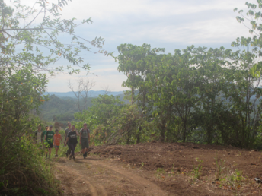
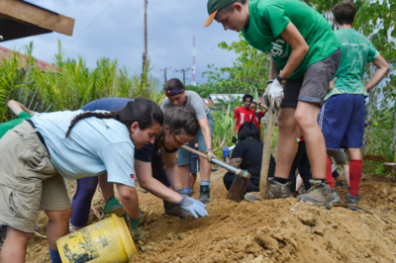
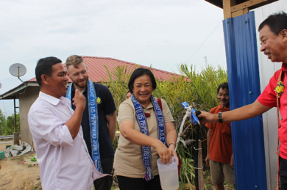

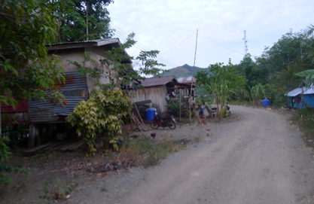
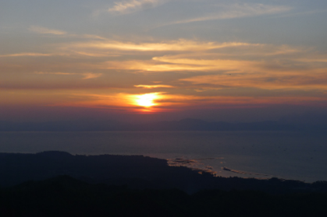
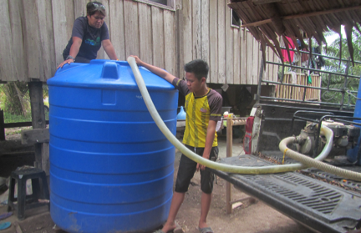

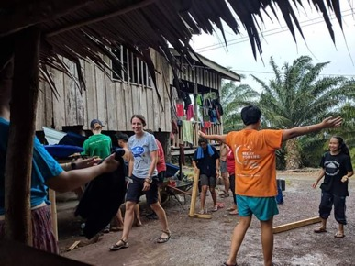
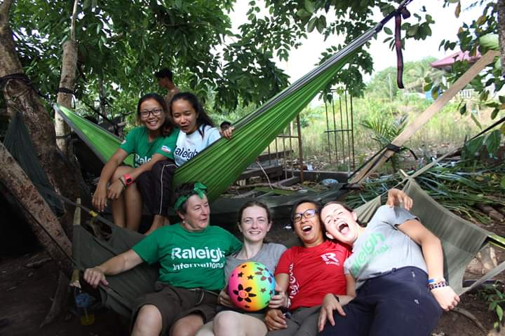
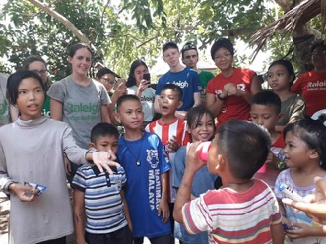

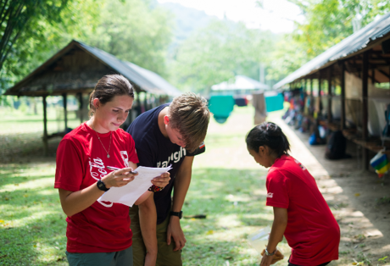
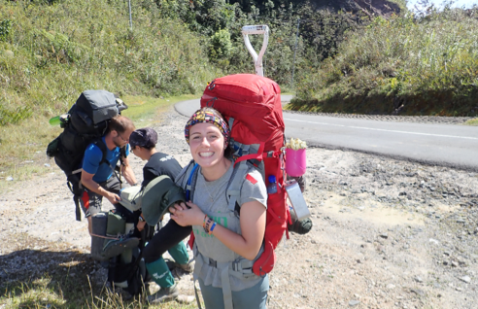
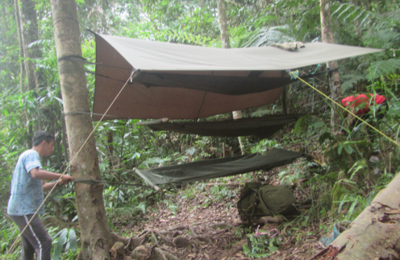
Phase 3 Trek

Trek phase was incredible! This 3-week phase is designed to challenge volunteers and was the most physically demanding phase. Volunteers carry their own personal equipment, part of the whole group’s food rations and some group kit also. It lasts 16 days and allowed my teammates and I to work together over some of the most incredible but difficult terrain we had encountered.
Every day we would awake around 4 am to pack away our personal kit, light the fire, collect water and pack away the group kit and leave the forest the way we found it (group tarp, radio, fill in slops pits etc) before hiking to the next destination. Most days we spent around 5-6 hours walking. We would then arrive at our area to camp for the night and set the whole camp up and cook over a fire with our wonderful Raleigh rations...! Before doing it all again the next day.
- 16 day trek through the Crocker range
- Carrying all group equipment and personal kit
- 9 days of rations carried between the team
- Survival training
- Focus on leadership skills and teamwork

This phase taught me that we are all so much stronger than we believe. It also taught me that there is a great deal of value and strength in a team and everyone can contribute meaningful skills that make the team stronger. I learned an element of selflessness and genuinely how to put others before myself. It was such fun and this phase allowed me to get a true sense of adventure sleeping in the forest with merely a hammock and tarp. We washed (occasionally) in the most glorious rivers and waterfalls and it was amazing to just feel in harmony with nature. I am extremely passionate about the outdoors and for me this phase allowed me to engage with a completely different environment to what I’m used to in the Scottish outdoors. It was amazing to see the people around me gain benefits from doing so as well. The sheer simplicity of looking after one another and just making sure camp life was running smoothly each day was wonderful. It was life in the most stripped back way I have and maybe ever will experience. This allowed such strong team bonds to form and I learned a great deal about myself without the fog that can sometimes be present in day to day life at home. Despite it being glorious oh my it was tough and some days even Ken’s (one of the jungle guides) most enthusiastic warm ups failed to loosen our tight muscles. However, we grew and became stronger as a team physically and mentally and by the end we could easily get our own bags on even though on the first Trek day we could barely lift them off the ground! We gained so much, and the guides were incredible people to be around and absorb knowledge from. We gained such cool survival skills; learned to light fire with just a small amount of coconut husk and if you can find bamboo in the jungle you are going to be alright.
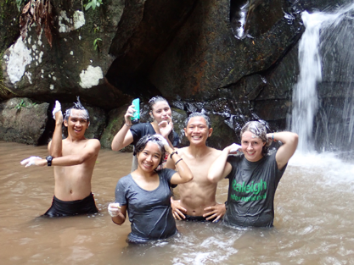
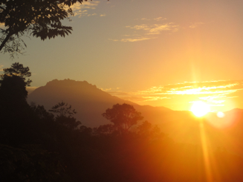
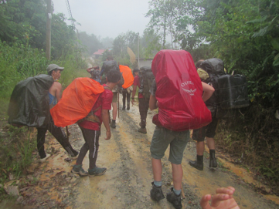

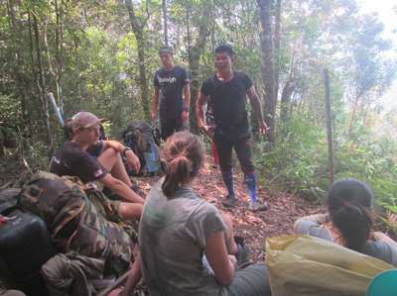
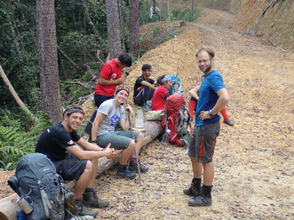
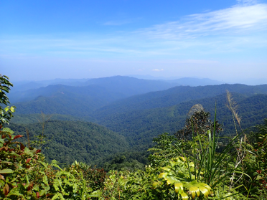

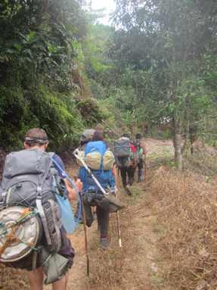

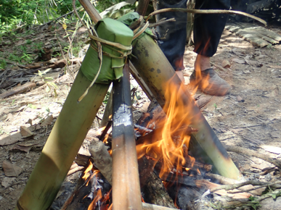
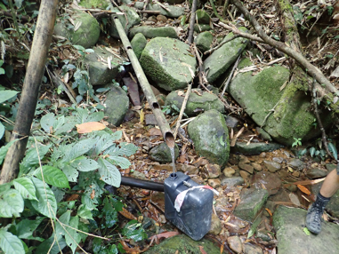

Highlights
A particularly hard section for me to be concise with so I will mention a highlight from each Phase. Phase 1 highlight has got to be on one of our days off work we were all relaxing in camp and a female orangutan with her baby swung round the trees at the edge of the camp and began feeding off a fruiting tree. Seeing Orangutans in the wild was just fantastic and made me rather emotional. We were extremely lucky to see Orangutans on a few other occasions too and each time was just so very special. It was incredible to remind ourselves of what a special place we were. We were so privileged to be in such an interesting environment. Phase 2 highlight was most definitely when we arrived in Mempakad. As we got off of the bus the village could not have been more welcoming, and they had prepared a feast of local foods! They also had collected fresh coconuts which they opened and let us drink from. The children immediately started playing games with us and were eager to learn English. It was as if we were being welcomed into one huge family from the very start and this generosity and warmth continued for our whole stay. Connecting with people from different cultures and walks of life is so vital to reminding everyone we are all mankind and can always share love, laughter and kindness even when living in the most basic and challenging conditions. Phase 3 highlight was when we were in Rogan Ghost camp it had been a huge effort to get there after a day of all uphill walking. The camp was situated at the very top of a hill. In the morning as we lay in our hammocks, we witnessed such a beautiful sunrise. The sun appeared from behind Mount Kinabalu and flooded our camp with light and warmth. It was one of the moments where I remember just feeling so completely grateful for all I had and just felt so content with myself and the world. This feeling is what adventure is all about.
This report has probably made Raleigh seem like the loveliest most beautiful and wonderful experience but believe me it was tough at times. Being away from home with no contact for 10 weeks was tough, it was wonderful to experience but at times you just wanted to phone a friend and tell them all that was going on miles from home. Going to bed soaked in sweat knowing you wouldn’t be washing until the next week was tough, cooking for a group of hungry people over a fire with Raleigh rations in the pitch black using mess tins was tough, waking up in the middle of the night getting wet because you hadn’t quite positioned your tarp correctly was tough, accidentally taking fire ants into your sleeping bag was tough , knowing you had to shake your sore body from your hammock at 4am to begin walking for the day was tough, being stung by hornets 4 times after walking through a nest and having to hobble for 2 hours to the next camp while continuously falling over due to your ankle being the size of your thigh…you guessed it was tough. BUT I can honestly say it was the most fantastic brilliant time I have ever experienced every day was new, people could be themselves and together we achieved such wonderful things and that was certainly not tough. When the going gets tough, the tough get going. I have never got going as much as I did whilst on expedition and I will keep going long into the future knowing I can overcome most things that may come my way.
How do I feel now it is over?
Raleigh expedition ending was difficult. Home was a big culture shock and not having to work hard to obtain water, and living in comfort was oddly difficult to adjust to. Being around people who were excited to hear the stories but didn’t truly understand what I had been through. I had thrown myself into every aspect of expedition and I was extremely sad when it ended. I had grown to love the people who had been strangers at the start of the 10 weeks as my new extended family. We had things that would never again be replicated a truly unique experience for us all to hold and treasure. Raleigh expedition gave me the opportunity to be around likeminded people with a common goal and worked really hard to achieve that goal. I think every single person had expectations of what they may learn and how they would find life away from society and technology for 10 weeks. However, I really don’t think anyone expected to connect with each other and the people we worked with in Malaysia as much as we all did. It was amazing to be around happy, motivated, hardworking and kind people. The attitudes of some of the men and women I encountered will inspire me to continually try to be better and encourage those at home to believe there can always be more to life than just going through the motions. To watch and learn from people who have less in possessions but are genuinely happier was just amazing. Also having moments to allow yourself to just appreciate where you are at that exact moment in time was magic. Loosing yourself amongst some of the tallest tropical trees in the world or by some of the most incredible waterfalls and pools and just breathe, away from media, away from negative people with negative words was something I will strive to find at home. I have always found myself most happy in nature and always strive to find adventure and exploration at home whether that’s a hill walk near my house or woodland walk with a friend. Everyone can explore don’t hesitate, you aren’t too weak, you aren’t too old, you aren’t too poor or not educated enough. There will always be people willing to help and support whether that is encouraging words or financial aid. Just pack your bag and take the first step. Exploration doesn’t always have to be far from home or last weeks it can be found just outside the front door and I hope everyone finds their own adventure whatever that may be.

Financials
I managed to secure grants from The Get Exploring Trust Fund, The Rosyth Gothenburg Trust and The Rosyth Community Council. I also had a just giving page set up and completed The West Highland Way as a sponsored 5 day walk to raise funds, I gained a great deal of support from family and friends on my page. I also worked.
Get Exploring Trust
Once again I would like to offer my sincerest thanks to everyone at The Get Exploring Trust for giving me financial support. However aside from the money knowing that there are people out there that believe you are taking part in something worth doing is extremely beneficial to believing in yourself as well. It is amazing to know there are people that want to encourage young people to learn and grow an the most exciting way. I found my expedition so beneficial to my physical and mental strength and awareness of myself and others and the world we live in. I feel like a very resilient and grateful individual and I hope to continue adventuring and encouraging others to do so too. At home I hope to encourage young people to challenge themselves and spread awareness that there are kind people who are ready to support. I do hope that in the future I will be able to give back and help someone young that might need financial support much like myself when I am able to do so.
Contact
Please if you have any questions about anything above do not hesitate to contact me. I can give further info on my experience, funding tips or even just if you want someone to offer advise or some kind words of encouragement 😊
Megan Kirk
megankirk77@hotmail.co.uk

Thanks for taking the time to read about my time in Borneo
With thanks to Daniel Buttifant, Sophie Babbs, Hwu Ning, Will Tucker and Hana Sanadi for photos

